2023-09-29

Abstract

This paper advances our understanding of the extent to which conventional deep learning methods can be applied to satellite imagery to capture the composition of primarily urbanized landscape. The building blocks that make up those -the activities and agents conceptualised as urban function and the structure that supports them conceptualised as urban form- can be spatially arranged in many ways. This paper relies on the concept of “spatial signatures”, a characterisation of space designed to understand urban environments, dependent on data sources released at a variable rate, limiting update frequency - an issue that could be resolved by remote sensing and satellite imagery. Using open data, we explore this pathway with the Sentinel-2 imagery within deep convolutional neural networks and predictive modelling trained to identify spatial signatures across Great Britain. While deep learning is established in the analysis of urban satellite imagery, its application has often ignored the geographical nature of the images. Our focus is not only to develop a performant model but also to learn about the effect of geographically-explicit methods of doing so. The results indicate that classification of predominantly urban environments is more challenging than that dealing with non-urban areas. However, the accuracy is competitive with established land cover classification models, especially when applying geographically-explicit methods. This suggests that satellite imagery presents a promising source and reflect form and function of urban environment in greater detail than is usually present in available remote sensing products.

[1][2][3]  
**Daniel Arribas-Bel**[4][5]  
*Geographic Data Science Lab, University of Liverpool*   
*The Alan Turing Institute*

Key words: .25em spatial signatures, classification, remote sensing, artificial intelligence, open data

# Introduction

The way in which different urban functions are arranged within space, and the forms these give rise to, are important to understand how cities work, how they interact with the human and environmental systems that create them, and how policy can effectively intervene. Urban form and function matter, at least, for two reasons [@dab_mf_2021a]: first because cities use both to encode their history; and second because, once in place, the physical layout of functions within a city condition how it can and will develop in the future. A key requirement to understand form and function in cities is adequate measurement, which implies detailed, consistent, and scalable characterisations that can be updated frequently over time. These characteristics then allow not only to observe detail, but to see it unfold both over space and time. There is a large literature measuring these phenomena, and it is relatively common to find any two of those characteristics (i.e., detailed and consistent, consistent and scalable, and detailed and scalable) present in a given piece of work. Research bringing the three together is still rare, although some is emerging (e.g., [@fleischmann2022geographical]) thanks to the confluence of better data, open source software, and cheap computing power. Still, generating detailed, consistent, and scalable classifications of urban form and function is an expensive process that is difficult to refresh regularly because most of the underlying data sources only see updates infrequently.

A promising option to improve the frequency of these classifications is satellite imagery. Satellite technology has radically increased and improved the amount of data available on the Earth, and shows no signs of slowing down. More and better imagery has been complemented with the rise of new computer vision algorithms, such as deep learning [@lecun2015], that allow to extract more value from the same amount of data; and the availability of computing power that makes it possible to deploy them cheaply without the steep learning curve required only a few years ago. The convergence of these three trends in remote sensing is unlocking achievements that even very recently seemed beyond the realm of possibility. One such area is the use of remote sensing and satellite technology to decode complex patterns in urban landscapes, such as the spatial signature of different types of form and function. Just as importantly, many of these advances are being built atop technology developed under open licenses that allow to further build on them, freely redistributing downstream outputs.

The use of satellite technology for measuring different aspects of urban environments is by no means new. Much of the present work falls within the broad category of urban remote sensing [@rashed2010remote; @weng2018urban; @yang2021urban]. In fact, the promise of using remote sensing data to decode the complexity of urban structure has long been recognised (e.g., [@longley2002geographical]). Much of the work in this area has traditionally focused on identification of individual geographic features, such as building footprints (e.g., [@microsoft2019]) or trees (e.g., [@ke2011review]). More recently, the field has started to pay increasing attention to the use of modern algorithms such as deep learning [@lai2021deep], and attempting to map more complex patterns that involve bundles of features rather than a single one (e.g., [@kuffer2021mapping]). On the adjacent domain of Land Use / Land Cover (LULC) mapping, recent advances have shown the potential of using frequently updated, open satellite data in combination with modern computer vision to effectively map land cover globally in quasi continuous ways (e.g., [@karra2021global; @brown2022dynamic]; see [@venter2022global] for a detailed comparison of some of the most novel data products in this realm).

While most of the efforts in urban remote sensing have focused on the identification of individual features or single uses, much less work has been directed at decoding patterns that involve several features and/or uses to be identified. In some ways, the jump from the simpler goal of identifying one object or a single use to detecting a pattern that involves a particular bundle of them is not without its challenges and shortcomings [@wang2022knowledge]. But, given the performance of modern algorithms, and the increase in resolution and quality of even openly available imagery, realising this goal is starting to become possible. There are two areas that have received most of the attention in this context. One revolves around the prediction of Local Climate Zones (LCZs, [@stewart2012]). LCZs are a set of pre-defined classes of urban fabric originally developed for the study of the urban heat island effect. A growing body of literature has focused on developing more exhaustive and sophisticated models to extract these classes from satellite imagery (e.g., [@koc2017mapping; @wang2018mapping; @liu2020local; @taubenbock2020; @zhou2021parcel; @zhou2022deep]). The second one is focused on one particular type of urban form and function that is mostly found in regions which are typically data scarce: informal settlements, or urban slums. For the interested reader, [@slums2016] provides an excellent starting point. Although much more in its infancy, a nascent area of interest is growing around using imagery to decode urban form (e.g., [@04f9ab8f6c714010ac39b58230f59d85]).

A common element of the recent advances reviewed above is the use of deep convolutional neural networks to perform the task of interest (i.e., classification/segmentation/recognition) from satellite imagery. Some studies, particularly those with sufficient data and computation available, train networks from scratch. These involves sometimes building a bespoke architecture (e.g., [@othman2017domain]), bespoke data for training (e.g., [@qiu2020fusing; @karra2021global]), or both (e.g., [@taubenbock2020; @zhu2022urban; @sharma2017patch; @wang2018multi]). Other works however rely on existing architectures like VGG/16 [@simonyan2014very], UNet [@ronneberger2015u], or ResNet [@he2016deep]; standardised databases such as ImageNet [@ILSVRC15] for training; or both (e.g., [@qiu2020fusing; @karra2021global; @srivastava2019understanding]). The letter is known as *transfer learning* and usually involves re-training of the top layers of the network to customise predictions to the specific use case, while retaining unchanged the original weights for all the other layers.

While deep learning has been recently introduced in the analysis of urban satellite imagery, its application has so far mostly ignored the geographical nature of the images being fed to these algorithms. This is not entirely unreasonable. Much of the state of the art in deep learning and computer vision was developed in the last decade with “aspatial imagery” in mind, in particular consumer photographs uploaded and shared through the internet (e.g., featuring cats and dogs). As such, many of the assumptions (e.g., unrelated images), tricks (e.g., data augmentation techniques), and limitations (e.g., shape of the input data) these models feature are intimately related to data of this kind. The application of deep learning to satellite imagery is in what we consider a first phase in which cutting edge computer vision has been deployed to images that, rather than animals or people, represent locations on Earth observed from above. Because of the overall impressive performance of modern algorithms, the results are impressive, even with largely unmodified models. However, this does not imply there is no further margin for improvement.

With many existing methods, there is a tendency towards a simplification of urban environment. In the most simple cases, we can talk about differentiation between built-up areas and non-built-up land, occasionally expanded to a few gradual steps in between (e.g. degree of urbanization by [@DIJKSTRA2021103312]). Land use and land cover classifications focus primarily on non-urban landscape, leaving all patterns that make up cities in a handful of classes. LCZ classification is based on pre-defined conceptual classes designed with an RS application in mind, omitting distinctions that are not easy to see on imagery. The understanding on how many types of urban insight can be seen from above is still very much an unexplored area.

This paper advances our understanding of the extent to which conventional deep learning methods can be applied to satellite imagery in order to capture the composition of primarily urbanized landscapes. It starts from an existing classification of Great Britain that is data-driven, designed to best capture urban form and function from available data (i.e. it is not designed to be seen on satellite imagery), and that flips the ratio of urban vs non-urban classes compared to most LULC classifications. From there, we move towards answering whether we can reliably detect this type and granularity of urban classification from open satellite imagery. Furthermore, given the geographical nature of the task, whether the is scope for spatially-explicit methods built on top of the output of neural network to bridge the gap between computer vision and geography? Understanding these topics can potentially allow development of a time series of otherwise static classifications like the one used in this paper and uncover the evolution of urban form and function in cities. The remainder of the paper is structured as follows: Section 2 describes the data we use as well as the methodological strategy we follow; Section 3 presents the key results from our experiments; and Section 4 discusses their relevance and concludes.

# Materials and Methods

In this section, we present the materials used in the research - the British spatial signatures we would like to identify and Sentinel 2 satellite imagery - and methods designed to understand our ability to train a conventional model on such a task and to unpack the role of geography in image-based deep learning.

## Materials

The research uses only two data inputs, one representing the "ground truth" we aim to predict using neural networks and the other representing satellite imagery. While the latter does not need much introduction, the British spatial signatures used as labels need to be explained further.

### British Spatial Signatures

Spatial signatures are a classification of space covering the entirety of a case study area. They are defined as *"a characterisation of space based on form and function designed to understand urban environments"* [@dab_mf_2021ap.4]. This definition points at the clear distinction between signatures and traditional LULC classifications. Taking the example of CORINE [@europeanenvironmentagency1990] as a representative of LULC, it has 44 distinct classes, out of which 2 cover urban form, and six other can be loosely related to urban areas[6]. A similar situation arises with recently released global LULC datasets. European Space Agency’s WorldCover project distinguishes 11 classes, of which one is urban (Built-up) [@zanaga_daniele_2021_5571936]. Esri’s Land cover has 9 classes: one is *Built Area*, and the rest covers unbuilt areas [@karra2021global]. This ratio of built vs unbuilt classes is typical but not very suited for research applications focusing on urban environments. Spatial signatures invert this ratio as they are primarily classifying urban space.

There are two main concepts embedded in spatial signatures delivering urban-focused classification. The first one is the spatial unit called the enclosed tessellation cell (ETC). To derive ETCs, [@dab_mf_2021a] first generate *enclosures*, spaces fully enclosed by a set of barriers (roads, railways, rivers, coastline). ETCs are an outcome of Voronoi tessellation based on building footprint polygons. The resulting spatial unit has adaptive granularity reflecting the scale of each urban pattern. The second is the selection of characters describing each ETC. They measure form and function, primarily urban phenomena and mostly omit environmental aspects focusing on land cover patterns. However, spatial signatures depend on a wide range of data inputs that are being updated at a variable rate. Some in monthly snapshots but others, based on census data, only every ten years. Given this heterogeneity, it is nearly impossible to provide a consistent yearly time series of their evolution. This is where remote sensing based on satellite imagery may help.

As presented in [@fleischmann2022geographical], British spatial signatures are one application of the concept of spatial signatures in the context of Great Britain. It divides the space into the 16 data-driven classes (Figure 1) listed in Table 1. Out of these 16 classes, nine are entirely urban, four are peripheral, and only three classify natural spaces, inverting the ratio of built vs unbuilt classes common in LULC. However, out of these 16 classes, some are very rare, and it would not be feasible to attempt to predict them. Therefore, we merge five classes under the "urbanity" group into a single one and use the resulting 12 classes throughout this paper, while using entirety of Great Britain as a study area. A note of caution on the delineation of these classes is warranted. While maps like those in Figure 1 implicitly convey the idea of clearcut boundaries between signature types, reality is much more complex. Thus, boundaries between signatures should be taken as [@fleischmann2022geographical]’s best estimate at delineating each area, but also on the understanding that reality is much more fluid, porous, and fuzzy.

Classes of British spatial signatures and their coverage in terms of area and a number of ETCs. Urbanity classes marked with * are combined for the experiments presented in this paper.

|  |  |  |  |  |
| --- | --- | --- | --- | --- |
|  | area (sq.km) | ETC count | area (%) | ETCs (%) |
| Signature type |  |  |  |  |
| Countryside agriculture | 93,856.1 | 3,022,385 | 41 | 21 |
| Accessible suburbia | 2,244.5 | 1,962,830 | 1 | 14 |
| Dense residential neighbourhoods | 957.2 | 502,835 | 0 | 3 |
| Connected residential neighbourhoods | 565.4 | 374,090 | 0 | 3 |
| Dense urban neighbourhoods | 570.6 | 238,639 | 0 | 2 |
| Open sprawl | 5,081.5 | 2,561,211 | 2 | 18 |
| Wild countryside | 91,306.3 | 595,902 | 40 | 4 |
| Warehouse/Park land | 2,462.4 | 707,211 | 1 | 5 |
| Gridded residential quarters | 261.2 | 209,959 | 0 | 1 |
| Urban buffer | 31,588.8 | 3,686,554 | 14 | 25 |
| Disconnected suburbia | 708.9 | 564,318 | 0 | 4 |
| Local urbanity* | 231.1 | 86,380 | 0 | 1 |
| Concentrated urbanity* | 7.8 | 1,390 | 0 | 0 |
| Regional urbanity* | 76.4 | 21,760 | 0 | 0 |
| Metropolitan urbanity* | 16.5 | 3,739 | 0 | 0 |
| Hyper concentrated urbanity* | 2.2 | 264 | 0 | 0 |

|  |  |
| --- | --- |
|  |  |

Figure 1: Spatial signatures in the full extent of Great Britain (right) and zoomed to a metropolitan area of the Scottish Central Belt stretching from Glasgow to Edinburgh (left), limited to 12 classes used in this paper.

### Sentinel 2 imagery

The second data input used in this research is satellite imagery provided by the Sentinel 2 mission. Specifically, we use the pre-processed cloud-free mosaic of Sentinel 2 released by [@CORBANE2020105737]. The mosaic provides pixel-level composite based on imagery for the period January 2017- December 2018 at an original resolution of 10 meters per pixel. While Sentinel 2 captures many spectral bands beyond traditional visible red, green and blue (RGB), this research uses only RGB bands due to its employment of pre-trained neural networks stemming from non-satellite imagery that is composed only of RGB and an attempt to minimize training from scratch that would need to happen to derive weights for other bands. The exclusion of other bands may be seen as a limiting factor of the work, but we believe that, as with other aspects that will be discussed later, it efficiently illustrates the *lower bound* of the performance of the presented method and can be only improved with the addition of other spectral bands or other data (e.g. synthetic-aperture radar imagery).

Another notable aspect of the Sentinel 2 imagery is the resolution. Ten meters per pixel may be enough to distinguish LULC classes, as shown by the examples discussed above. However, it is unclear whether it is enough to delineate types of urban environments. Individual buildings often do not stretch beyond the spatial extent of two pixels, which is severely limiting what we can *see* on the image, as illustrated in Figure 2. While other data sources may provide better resolution[7], potentially improving model performance, this research is bound within the limits of *open data*, where Sentinel 2 is the best offering to date.

## Methods

We define our challenge as an image classification task and use competing alternatives to explore which one performs best and to assess whether the *best* is good enough. Each of them implies geographically relevant trade-offs. First, we build and train a model composed of a convolutional neural network and probability modelling able to predict the 12 classes derived from the spatial signatures. Second, we use methods designed to unveil which of the inherently geographical decisions being tested has a significant effect on the resulting performance and should therefore be considered when applying CNN to spatial problems.

When selecting the CNN architecture, we have intentionally excluded image segmentation. While it seems like an ideal candidate for the task at hand, there are several reasons for its exclusion. The first has to do with the spatial signatures and the nature of the boundaries between individual types. While the dataset from [@fleischmann2022geographical] delineates them with hard boundaries when one cell is a type A and the neighbouring one a type B, the reality is not that simple, and these boundaries should be treated more as a fuzzy edge that the hard one. There is very rarely an immediate switch between one type of urban environment and the other one. In many cities, two types tend to form a transition on the edges where neither is dominant. A situation like this is very challenging for the image segmentation as it often looks at delineation of water bodies, buildings or other precisely defined patches on an image. The second reason is that the image segmentation, having a prediction for individual pixels, would not allow us to use the second part of the method and test the effect of spatial lag in modelling efficiently. The only way of doing that would be to run the experiment on a pixel level which would be extremely computationally expensive, hence challenging to reproduce. We believe that the method that can be run on a local machine is in the end, more valuable than the one requiring a high-performance cluster.

Overall, our exercise is structured as a comparison of models that attempt to predict the 12 spatial signatures entirely from Sentinel 2 imagery. Each model 1) takes a set of training data as input; 2) runs the class prediction using the convolutional neural network (CNN); and 3) builds a (spatial) model on top of the resulting probabilities. The differences between the models are capturing the geographical options that are being tested: extent of the area sampled from the satellite imagery into a single *chip*, presence of spatial augmentation, class exclusivity within each chip, and an architecture of probability modelling on top of a prediction coming from the CNN. Finally, the performance of each model is assessed using both traditional non-spatial techniques used in deep learning and bespoke spatial metrics. Given a large number of resulting values, a regression approach is used to determine the effect of the tested options. Each of the steps is further discussed in detail in the subsequent sections.

### Chip size

The first question that needs to be answered when trying to apply a classification algorithm on satellite imagery that spans a large amount of continuous land is how to sample such data into individual patches (or, hereafter, chips) that can be assigned to classes. Pre-trained CNNs usually expect a square image of a certain size, but that does not mean that the same size (in terms of pixels) needs to be directly sampled from the image, thanks to possible resampling. What should be retained, though, is the ratio. Therefore, we need to sample square chips of a custom size. Within an image classification framework, which is the first type of model that is tested, we assume that each chip contains data of a single class only. Therefore, such a chip should be entirely within the boundary of a single signature type. That poses some restrictions as spatial signatures, especially in the urban context, tend to be relatively granular, and large chips would not fit inside the boundaries, reducing the number of valid chips for training. Therefore, the goal is to find a balance between the number of chips sampled from the data and the amount of information each chip can hold. Given the relatively coarse resolution of Sentinel 2, a chip of 100x100 meters consists of only 10x10 pixels, which may not be enough to capture the nature of a signature type and distinguish it from other types. On the other hand, a chip of 1000x1000 meters, which is likely large enough to capture the difference, will not fit in most of the signature boundaries and we would end up with only a few chips per urban class.

The literature rarely discusses the decisions involved in defining the chip size for single-class chip classification. In some cases, the size is predetermined due to the requirement of either a pre-trained model or an existing set of labelled data [@taubenbock2020]. In others, the size that has been used in previous studies is applied again without discussing the implications of such a decision [@wang2018mapping]. From a spatial analysis perspective, this approach is surprising as deciding the chip size is a prime example of the modifiable areal unit problem (also known as MAUP, [@openshaw1981modifiable]), especially the aspect about scale, which states that a change of the scale may affect the outcome of an experiment. Hence such an effect should be at least considered in an interpretation if not minimized where possible.

In this work, we try to understand the effect of chip size by testing all the models based on four different chip sizes - 80, 160, 320 and 640 meters representing chips of 8x8, 16x16, 32x32 and 64x64 pixels, respectively, illustrated on a Figure 2 and a Supplementary Figure 11.

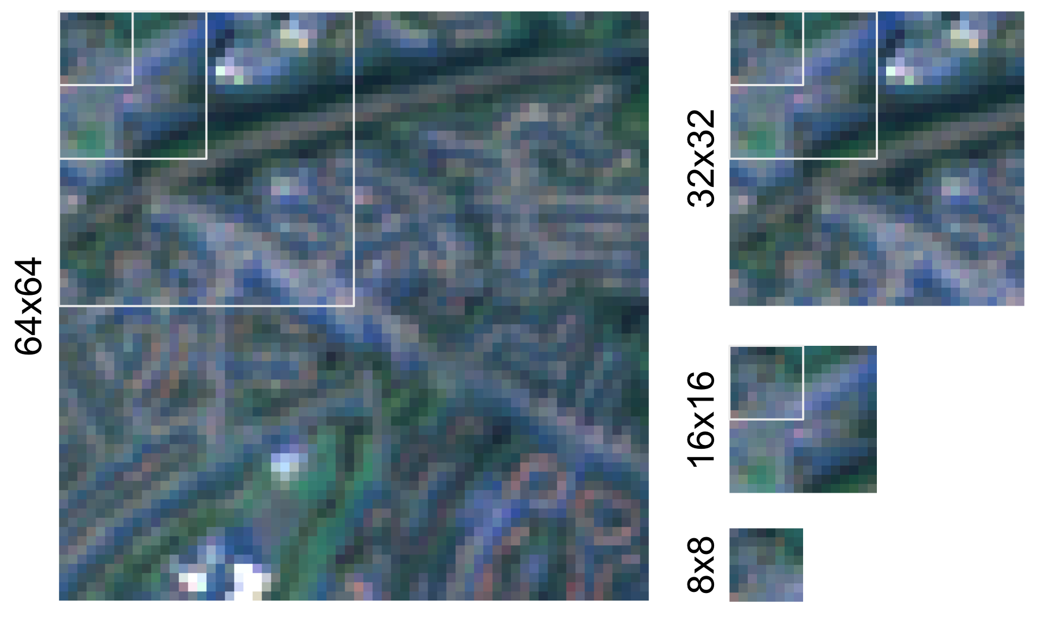

Figure 2: Illustration of the selected chip sizes using the Sentinel 2 cloud-free mosaic. Each of the chips also shows the sizes of the smaller options as a white outline.

### (Spatial) data augmentation - *Sliding*

As mentioned above, in combination with the signature geometry and the requirement to keep chips exclusively within a single class, specific chip sizes may result in insufficient training data for some signature types causing imbalance in the training set. Under-sampling like this one can be a serious problem that is not unique to spatial modelling. However, traditional augmentation methods are not directly applicable here. For example, in an image classification problem trying to determine if there is a cat or a dog on an image, we add some rotation or zoom to get more versions of the same image and expand the set of training data. Neither of these methods is applicable to spatial problems. Rotating the image would break natural light conditions, while zooming in would change the scale of the urban environment we attempt to capture. Moreover, distinction between some signature types is partially in different orientation of streets, rendering rotation-based augmentation counter-productive.

At the same time, the geographical and continuous nature of the data at hand allows us to use explicitly spatial augmentation techniques such as the one we call *sliding*. Sliding can be seen as overlapping sampling. Instead of overlaying a grid of chips over target geometry and using each pixel only once, we take the initial grid and slide it a few pixels horizontally and vertically, as illustrated in Figure 3. If the boundary of a slid chip is fully within a signature geometry, it is added to the pool of chips to be used. This process is done repeatedly to ensure that each class has a reasonable amount of chips to work with, while chips from the large signature types are intentionally undersampled to retain a relative balance between the classes in the training data.

It is to be noted that sliding can cause data leakage (sequences of pixels being present in both training and validation) if done before splitting the data into training and validation subsets. Therefore, we first create the initial grid, subdivide it spatially into four parts (40% for CNN training, 10% for CNN validation, 40% for probability modelling training, 10% for probability modelling validation) and apply sliding within each part to avoid any pixels being shared among chips from different sets. Subdivision into the four parts is done within each signature geometry to avoid potential geographical bias.

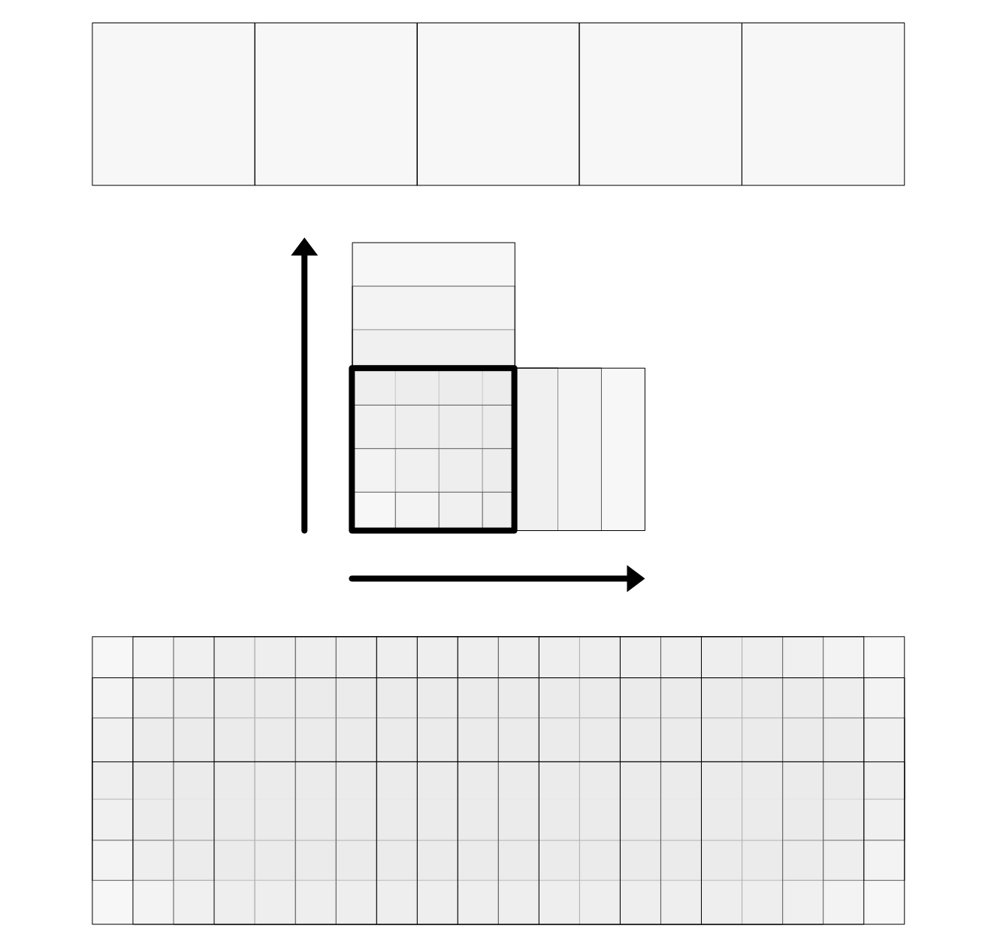

Figure 3: Diagram illustrating the sliding mechanism. The first row shows the initial non-overlapping grid, the last one final overlapping set of chips.

### Model architecture

Model architecture refers to the analytical pipeline that transforms chips into a prediction for a single signature type. Our competing architectures contain two main parts. First is a CNN that transforms a single chip into a set of 12 probabilities, one for each signature type. Second is a mathematical function that converts such probabilities ( considering only those for the chip of interest or in conjunction with those of neighbouring chips) into a prediction for a single signature type. This section describes each of these in detail. We would like to highlight that, contrary to the majority of deep learning-focused research, our focus is not on the architecture of the CNN itself. We assume the effect of geographic choices will largely show similar behaviour irrespective of the network architecture. For that reason, throughout our experiments we use EfficientNetB4 [@https://doi.org/10.48550/arxiv.1905.11946], pre-trained on the popular ImageNet dataset [@deng2009imagenet]. Appendix 5.1 shows a brief comparison of several standard neural network architectures and their performance on a subset of data to motivate our decision. We then apply transfer learning by re-training the top layer of the pre-trained model and replacing it by a custom sequence of dense layers described below.

We consider three variants of the CNN. The default approach (which we will refer to bic, for “baseline image classification”) is a standard image classification problem, using the sets of chips that are fully within a single signature type. The custom top layer of the pre-trained CNN then contains a Global Average Pooling (2D) layer, a dense layer with ReLu activation and 256 neurons, and a dense layer with the softmax activation and a number of neurons equal to a number of classes (12). The result for a single chip is a collection of 12 probabilities of a chip belonging to each signature type. The sum of all probabilities is one. An extension of this approach (sic, for “sliding image classification”) applies this technique to the data being spatially augmented with the sliding technique described above.

Our third approach recasts the image classification task as a multiclass prediction. If we relax the requirement that every chip is fully within the boundaries of a single signature type, we end up with many more available chips, but now some of them include more than a single label within their extent. Instead of a single label per chip, we now deal with a 1-D array of them. This can be beneficial from the geographical perspective as such chips now inherently encode the co-location of individual signature types and a model could use this information during the prediction. As signature types usually tend to neighbour only a subset of other classes (e.g., Urbanity never neighbours Wild Countryside), we can assume that information on co-location can positively impact predictive performance. We then include a set of chips sampled from a grid crossing the boundaries of signature types (using the same chip sizes as before) and adapt the CNN to perform multi-output regression (mor) instead of image classification. This change implies the top layer is now composed of a Global Average Pooling (2D) layer, a dense layer with ReLu activation and 256 neurons, and a dense layer with the sigmoid activation and a number of neurons equal to a number of classes (i.e., 12). The result for a single chip is a similar collection of probabilities, but these are now predicted proportions. As such, the sum of all of them ranges between 0 and 12 rather than between 0 and 1.

A comparison of the total number of chips used by each CNN is available in the supplementary table 7. The split of chips is then 40% for CNN training, 10% for CNN validation, 40% for probability modelling training, 10% for probability modelling validation equally across all the options. All CNN models are trained using the following hyperparameters: number of epochs: 200, optimizer: Adam, patience: 5, and a batch size: 32. See the relevant code in the linked repository for details.

The second step in the pipeline takes chip probabilities and turns them into predictions of a signature type. To do this, we compare five approaches of differing complexity and sophistication. These five variants stem from the combination of two components: the set of inputs used to make the prediction and the function transforming them into a single signature type. For a given chip $i$, we can express this step of the pipeline mathematically as follows:



where $S_{i}$ is the prediction for the signature type of chip $i$ (one of the $k$ available types, where $k=12$ in our empirical case, see Section 2.1.1) and $f\left(⋅\right)$ is a function that transforms the inputs $P$ into $S_{i}$. The five approaches we compare derive from the different implementations of $f\left(⋅\right)$ and $P$. On the latter, we compare models that only use $P_{k−i}$ (probability that chip $i$ is of type $k$) generated by the CNN for chip $i$ (baseline) with alternatives (signalled with the wx term) that, in addition, also include an average of $P_{k−j}$ (probability that chip $j$ is of type $k$), which are the probabilities generated by the CNN for each neighbour $j$ of chip $i$. This is akin to what in spatial analysis is called the *spatial lag* of each probability, and is calculated using a spatial weights matrix $W$ that records the spatial relationship between every chip in the set. In our $W$, two neighboring locations $i$ and $j$ will receive a weight $w_{ij}=1$, if they are in the same of the four split sets as defined above, and if they either are geographically contiguous or are nearest neighbours; while otherwise they will be considered non-neighbours and receive a weight $w_{ij}=0$. To obtain an average of the neighbors, we row-standardise $W$ so that. The second dimension other than $P$ we vary is the function $f\left(⋅\right)$ that maps it to the prediction $S_{i}$. We take three distinct approaches here: simply picking the maximum probability (maxprob), which we only use without the spatial lag of probabilities; an ensemble of binary logit models to predict each class (logite), then selecting the class with top probability, which we also use with the wx variant; and a histogram-based gradient boosted classifiers inspired by LightGMB [@ke2017lightgbm] and implemented in scikit-learn [@pedregosa2011scikit]. This yields our five competing models: maxprob, logite_baseline, logite_baseline-wx, HGBC_baseline, and HGBC_baseline-wx.

### Performance metrics

The goal of our experiments is to compare different models under varying geographical conditions to learn both which performs best, but also how different choices of geographical nature influence the overall performance when predicting form and function from satellite imagery. To provide a workbench that systematically compares each model and setup, we use a set of performance scores that operate either at the global or class level, and that measure performance in the traditional machine learning sense, as well as in the spatial sense.

We use four standard performance scores. *Cohen’s kappa* score ($κ$, [@cohen1960coefficient]) is a measure of agreement between two sets of categorical labels that ranges from -1 to 1. Intuitively, it measures the extent to which the two sets agree with each other (i.e., same label for the same observation) beyond what would be expected from pure chance ($κ=0$). Cases where there is more disagreement than expected from chance receive a negative score. *Global (within-class) accuracy* captures the proportion of observations correctly predicted (in a given class). The *Macro F1* is a score that aggregates class-based F1 scores. The F1 is the harmonic mean between precision (proportion of chips predicted in one class actually belonging to that class) and recall (proportion of chips belonging to a given class being predicted as such). We use both the *weighted Macro F1* as well as the *averaged Macro F1*. The latter takes the standard mean of the F1 scores for each class, while the former weights each F1 by the proportion of chips in each class.

In addition to traditional performance scores, we also evaluate how similar the spatial pattern of predictions is to that of the original labels. The measures described above are all “spatially unaware” in the sense that they quantify different aspects of the correctness of a model’s predictions but ignore their spatial patterning. Two sets of results may have the same amount of correct predictions, but in one, the spatial layout of such predictions may be close to that of the observed labels, while the other one spatially allocates mispredictions in a way that differs more from what is observed empirically. Given the nature of our classification challenge –identify form and function over space from satellite imagery– the spatial dimension of model performance is of great importance. Since the spatial signatures represent a set of (12) distinct categories, we rely on the *join counts* statistic (JC, [@cliff1981spatial]). The JC measures the degree of spatial concentration in a binary categorical variable; hence, we use it at the class level. For each class in each model, we retain the proportion of pairs of chips in the same class that are spatial neighbours (“joins”) over the total number of pairs that are spatial neighbours. Our neighbourhood definition relies on two alternative spatial weights matrices: one based on a distance threshold of $1Km$ ($W_{thr}$), and one that combines the nearest neighbour with those defined by contiguity ($W_{union}$). Our metric of interest is then the error (i.e., absolute value of the difference) between this proportion for the model of interest and that of the observed labels.

### Summarizing experiments

The setup described above generates over 60 different models to be trained to predict 12 signature types and six performance measures to evaluate them. Making sense of their results requires a systematic approach that summarises them and provides explicit tests for the questions we are trying to answer. We achieve this goal by fitting linear regressions that explain performance scores for each model as a function of the characteristics of the setup evaluated. Specifically, we estimate the following two equations. First, for global metrics, we run:



where $Perf_{i}$ is each of our four global performance scores measured for trained model in setup $i$; $α$ is an intercept; $M_{i}$ are indicator variables for the type of model we estimate (i.e., maxprob, logite, HGBC);[8] are, similarly, indicator variables for the architecture used (i.e., bic, sic, mor);[9] captures the number of pixels the chips in the setup contain; $W_{s}$ is another indicator variable that takes the value of one if the model includes the spatial lag of signature type probabilities and zero otherwise; and $ϵ_{i}∼N\left(0,σ\right)$ is an i.i.d. error term.

Second, for class-based scores, we fit:



where $\left[\%\right]Obs$ represents either the number of chips in signature $s$ in setup $i$ or as a proportion of the total; and $S_{i−s}$ an indicator variable for the signature type ;[10] and the rest is as in Equation [eq:reg_global]. Importantly for both equations, $δ_{m}/γ_{a}/β_{1}/β_{2}/β_{3}/ζ_{s}$, parameters to be estimated by the regression model, provide a direct and formal test to the key questions we set out to answer with our experiments.

# Results

Global accuracy is shown in Table 2. It may seem that the results are underwhelming but taking a closer look, it is true only for some models, usually using smaller chip sizes and simpler architecture. Out of 60 tested models, 14 have global accuracy over 0.5, 6 over 0.6 and one over 0.7. Compared to the relevant metrics from established LULC models, [@venter2022global] reports that ESRI’s Land Cover reaches global accuracy of .75, Google’s Dynamic World 0.71 and ESA’s World Cover 0.65, rendering our highest performing models at par with these. However, they do perform considerably worse than established LCZ models, that report global accuracy of 0.87 [@taubenbock2020]. Yet, this difference is expected as LCZ classes are designed with remote sensing in mind while spatial signatures aim to reflect the form and function independent of whether the distinction between two signature types shall be seen from satellite imagery. Nevertheless, global accuracy is far from providing the full picture.

Martin: [The JSON with HistGradientBoostingClassifier 16 BIC is corrupted, so we don’t know the value.]

Global accuracy of all the models tested in this study. Values higher than 0.5 are highlighted in italic, values higher than 0.6 in bold and a value over 0.7 in bold italic.

|  | Chip Size | B.I.C. | S.I.C | M.O.R |
| --- | --- | --- | --- | --- |
| maxprob | 8 | 0.30 | 0.32 | 0.29 |
| 16 | 0.27 | 0.35 | 0.28 |
| 32 | 0.42 | 0.34 | 0.35 |
| 64 | *0.50* | 0.46 | *0.58* |
| 1-2 | 8 | 0.32 | 0.35 | 0.31 |
|  | 16 | 0.36 | 0.36 | 0.31 |
|  | 32 | 0.46 | 0.36 | 0.36 |
|  | 64 | **0.60** | 0.47 | *0.58* |
| 1-2 | 8 | 0.34 | 0.41 | 0.33 |
|  | 16 | 0.42 | 0.46 | 0.33 |
|  | 32 | *0.52* | 0.48 | 0.39 |
|  | 64 | **0.67** | *0.55* | *0.59* |
| 1-2 | 8 | 0.32 | 0.36 | 0.32 |
|  | 16 | NaN | 0.37 | 0.33 |
|  | 32 | 0.48 | 0.40 | 0.49 |
|  | 64 | **0.62** | 0.48 | ***0.71*** |
| 1-2 | 8 | 0.35 | 0.44 | 0.35 |
|  | 16 | 0.44 | 0.47 | 0.34 |
|  | 32 | *0.54* | *0.50* | 0.40 |
|  | 64 | **0.68** | *0.56* | **0.63** |

Within-class accuracy by the model can be seen in Figure 4 (a sister figure where scores are grouped by signature rather than by model can be found in Appendix 5.2). We notice some consistent patterns already. The baseline image classification (bic) tends to underperform other architectures, especially on more urban signature types. On the other hand, multi-output regression (mor), and using the larger chip size (32 or 64), tends to show the highest values across signature types and models. If we look at accuracy for individual signature types, both extremes (urbanity on one side and both countryside classes on the other) tend to be the easiest to predict. Regarding the models, there is no immediate conclusion to be made apart from a clear indication that the maximum probability (maxprob) approach is generally worse than any of the modelling, suggesting that there is a value in the modelling step. The within-class accuracy can be further explored using confusion matrices available in Appendix 5.3.

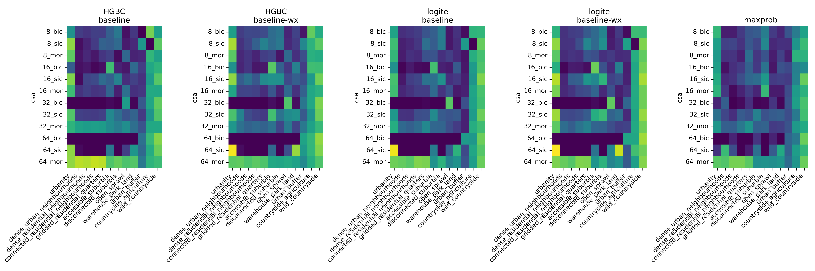

Figure 4: Within-class accuracy scores grouped by model. Each panel represents results from one of the five models compared, namely: histogram-based boosted classifier (HGBC) with features pertaining only to a given chip (baseline) or including also features from neighbouring ones (baseline-wx); Logit ensemble (logite) with the same two variations; and a simpler maximum probability approach (maxprob). Each row in the heatmap corresponds to a pair of chipsize (8, 16, 32, and 64 pixels) and architechture (baseline image classification, or bic; sliding image classification, or sic; and multi-output regression, or mor) used in the neural network stage of the pipeline. Colouring is standardised across panels and values range from 0 (dark purple) to 1 (bright yellow).

Whilst plotting the accuracy is a way to build an intuition about the performance of individual options, it does not quantify their effects. The linear regressions shown in tables 3 and 4 provide better insight. The first regression explains global performance scores (Cohen’s kappa, Global Accuracy, Marco F1 weighted and Macro F1 average). We can draw a few conclusions from this. First, the chip size seems to have a positive effect on the results, as it is consistently significant across all metrics. Except for the average macro F1 score, there is a positive effect of the inclusion of spatial lag in the modelling step (W). Regarding the CNN step, we do not see a lot of significance but there are indications that sliding image classification and multi-output regression approaches outperform baseline image classification. Comparing the probability modelling step, we see an indication that the maximum probability is the least performant of the options, again suggesting the value of post-CNN modelling.

Regression outputs explaining global non-spatial performance scores. Explanatory variables with a preceding (M) and (A) correspond to binary variables for the type of model (with histogram-based boosted classifier, or HGBC, as the baseline) and architecture (with baseline image classification, or BIC, as the baseline), respectively. Standard errors in parenthesis. Coefficients significant at the 1%, 5%, 10% level are noted with ***, **, and *, respectively.

|  | $κ$ | Global Accuracy | Macro F1 w. | Macro F1 avg. |
| --- | --- | --- | --- | --- |
| Intercept | 0.2185*** | 0.3236*** | 0.2790*** | 0.1798*** |
|  | (0.0209) | (0.0175) | (0.0174) | (0.0375) |
| (M) Logit E. | -0.0245 | -0.0256* | -0.0324** | -0.0325 |
|  | (0.0168) | (0.0141) | (0.0141) | (0.0302) |
| (M) Max. Prob. | -0.0559** | -0.0606*** | -0.0421** | -0.0296 |
|  | (0.0222) | (0.0187) | (0.0186) | (0.0399) |
| (A) M.O.R. | 0.0227 | -0.0357** | -0.0278* | 0.1787*** |
|  | (0.0184) | (0.0155) | (0.0154) | (0.0331) |
| (A) S.I.C. | 0.0232 | -0.0247 | -0.0171 | 0.1101*** |
|  | (0.0184) | (0.0155) | (0.0154) | (0.0331) |
| Chip Size | 0.0036*** | 0.0043*** | 0.0048*** | 0.0014** |
|  | (0.0004) | (0.0003) | (0.0003) | (0.0006) |
| W | 0.0572*** | 0.0468*** | 0.0531*** | 0.0392 |
|  | (0.0168) | (0.0141) | (0.0141) | (0.0302) |
| $R^{2}$ | 0.7214 | 0.8281 | 0.8514 | 0.4191 |
| $R^{2}$ Adj. | 0.6899 | 0.8086 | 0.8346 | 0.3533 |
| N. | 60 | 60 | 60 | 60 |

Table 4 then looks again at the within-class accuracy explaining what we have seen in Figure 4. Multi-output regression consistently outperforms both baseline image classification and sliding image classification (which shows inconsistent results itself). Chip size has, again, a positive effect on the performance, while the inclusion of spatial lag in the modelling also consistently shows a positive impact. As assumed above, the prediction of signature types on both extremes of the urban-wild range tends to be easier than classes in between, which are, conceptually, the most challenging to predict due to the higher amount of *transition land* between class core areas.

Regression outputs explaining within-class accuracy. Explanatory variables with a preceding (M), (A) and (S) correspond to binary variables for the type of model (with histogram-based boosted classifier, or HGBC, as the baseline), architecture (with baseline image classification, or BIC, as the baseline) and spatial signature (with Accessible suburbia as the baseline), respectively. Standard errors in parenthesis. Coefficients significant at the 1%, 5%, 10% level are noted with ***, **, and *, respectively.

|  | Within-Class Accuracy | | |
| --- | --- | --- | --- |
| Intercept | 0.1866*** | -0.0237 | 0.0595** |
|  | (0.0308) | (0.0311) | (0.0303) |
| (M) Logit E. | -0.0125 | -0.0125 | -0.0125 |
|  | (0.0159) | (0.0141) | (0.0146) |
| (M) Max. Prob. | -0.0188 | -0.0188 | -0.0188 |
|  | (0.0211) | (0.0186) | (0.0193) |
| (A) M.O.R. | 0.1753*** | 0.2512*** | 0.1753*** |
|  | (0.0175) | (0.0163) | (0.0160) |
| (A) S.I.C. | 0.1202*** | -0.0783*** | 0.1202*** |
|  | (0.0175) | (0.0209) | (0.0160) |
| Chip Size | 0.0014*** | 0.0041*** | 0.0014*** |
|  | (0.0003) | (0.0003) | (0.0003) |
| 1k Obs. |  | 0.0514*** |  |
|  |  | (0.0036) |  |
| % Obs. |  |  | 0.0156*** |
|  |  |  | (0.0013) |
| W | 0.0365** | 0.0365*** | 0.0365** |
|  | (0.0159) | (0.0141) | (0.0146) |
| (S)Urbanity | 0.2358*** | 0.2022*** | 0.2574*** |
|  | (0.0349) | (0.0309) | (0.0320) |
| (S)Dense urban neighbourhoods | -0.1420*** | -0.1075*** | -0.0998*** |
|  | (0.0349) | (0.0309) | (0.0322) |
| (S)Dense residential neighbourhoods | -0.1414*** | -0.0836*** | -0.0983*** |
|  | (0.0349) | (0.0311) | (0.0322) |
| (S)Connected residential neighbourhoods | -0.1306*** | -0.0726** | -0.0754** |
|  | (0.0349) | (0.0311) | (0.0323) |
| (S)Gridded residential quarters | -0.0785** | -0.0127 | -0.0049 |
|  | (0.0349) | (0.0312) | (0.0326) |
| (S)Disconnected suburbia | -0.0601* | -0.0103 | -0.0019 |
|  | (0.0349) | (0.0311) | (0.0324) |
| (S)Open sprawl | -0.0845** | -0.0995*** | -0.1143*** |
|  | (0.0349) | (0.0309) | (0.0321) |
| (S)Warehouse park land | -0.0857** | -0.0788** | -0.0817** |
|  | (0.0349) | (0.0309) | (0.0320) |
| (S)Urban buffer | -0.0828** | -0.1382*** | -0.1753*** |
|  | (0.0349) | (0.0311) | (0.0330) |
| (S)Countryside agriculture | 0.2236*** | 0.1593*** | 0.1118*** |
|  | (0.0349) | (0.0312) | (0.0334) |
| (S)Wild countryside | 0.3876*** | 0.3283*** | 0.2925*** |
|  | (0.0349) | (0.0311) | (0.0330) |
| $R^{2}$ | 0.4979 | 0.6087 | 0.5794 |
| $R^{2}$ Adj. | 0.4857 | 0.5987 | 0.5686 |
| N. | 720 | 720 | 720 |

The regression outputs explaining differences in the spatial pattern between observed and predicted values measured by the Join Counts statistic offer another - spatially explicit - perspective on the performance of tested model configurations. As such, it also indicates slightly different results as presented in Table 5. Neither option of the probability modelling steps seem to have a significant effect on the Join Counts results, unlike in previous performance metrics. However, the architecture of the neural network step shows a significant effect as multi-output regression, and in two out of four cases also sliding image classification, outperform the baseline image classification. While the effect of the chip size is inconsistent across the options, the inclusion of the spatial lag in the modelling step has a significant effect (at either 10%, 5% or 1% significance level). The effect of a signature type depends on its nature. More compact urban types like *Urbanity* and *Dense urban neighbourhoods* show significance when using a distance threshold spatial weights, while sparser signature types like *Open Sprawl* and *Urban Buffer* show significance when using a union of weights.

Regression outputs explaining (log of) differences in the spatial pattern between observed and predicted values, as measured by the Join Counts statistic. The Join Counts for each signature were computed using two types of spatial weights: one based on a distance threshold of 1Km ($W_thr$), and another one built as a the union of nearest neighbor and queen contiguity matrices ($W_union$). Explanatory variables with a preceding (M), (A) and (S) correspond to binary variables for the type of model (with histogram-based boosted classifier, or HGBC, as the baseline), architecture (with baseline image classification, or BIC, as the baseline) and spatial signature (with Accessible suburbia as the baseline), respectively. Standard errors in parenthesis. Coefficients significant at the 1%, 5%, 10% level are noted with ***, **, and *, respectively.

|  |  |  |  |  |
| --- | --- | --- | --- | --- |
|  | $JC$ | $log\left(JC\right)$ | $JC$ | $log\left(JC\right)$ |
|  | $W_thr$ | $W_thr$ | $W_union$ | $W_union$ |
| Intercept | 4.3454*** | 1.4617*** | 4.7103*** | 1.6311*** |
|  | (0.9507) | (0.1344) | (0.5763) | (0.1080) |
| (M) Logit E. | -0.1406 | -0.0431 | 0.1851 | 0.0481 |
|  | (0.4951) | (0.0700) | (0.2995) | (0.0561) |
| (M) Max. Prob. | 0.1128 | -0.1223 | 0.2819 | 0.0223 |
|  | (0.6442) | (0.0911) | (0.3887) | (0.0728) |
| (A) M.O.R. | -3.1630*** | -0.5744*** | -2.7875*** | -0.4647*** |
|  | (0.5494) | (0.0777) | (0.3301) | (0.0619) |
| (A) S.I.C. | 0.0119 | -0.2390*** | -0.6666** | -0.0481 |
|  | (0.5532) | (0.0782) | (0.3329) | (0.0624) |
| Chip Size | 0.0297*** | -0.0005 | -0.0061 | -0.0080*** |
|  | (0.0108) | (0.0015) | (0.0065) | (0.0012) |
| W | -0.9325* | -0.1376** | -0.9556*** | -0.1785*** |
|  | (0.4945) | (0.0699) | (0.2991) | (0.0560) |
| (S)Urbanity | 4.6650*** | 0.6574*** | 0.1156 | -0.1258 |
|  | (1.0696) | (0.1512) | (0.6460) | (0.1211) |
| (S)Dense urban neighbourhoods | 1.7796* | 0.5094*** | 0.7480 | 0.1609 |
|  | (1.0695) | (0.1512) | (0.6487) | (0.1216) |
| (S)Dense residential neighbourhoods | -0.8545 | 0.0672 | -0.4636 | -0.0920 |
|  | (1.0958) | (0.1550) | (0.6647) | (0.1246) |
| (S)Connected residential neighbourhoods | -0.3656 | 0.1543 | -0.4388 | -0.1447 |
|  | (1.1018) | (0.1558) | (0.6647) | (0.1246) |
| (S)Gridded residential quarters | -0.2000 | 0.1009 | -0.6203 | -0.2111* |
|  | (1.0744) | (0.1519) | (0.6517) | (0.1221) |
| (S)Disconnected suburbia | -0.9752 | -0.1719 | -1.0303 | -0.3358*** |
|  | (1.1213) | (0.1586) | (0.6684) | (0.1252) |
| (S)Open sprawl | 1.8342* | 0.1734 | 2.1575*** | 0.3576*** |
|  | (1.0604) | (0.1499) | (0.6432) | (0.1205) |
| (S)Warehouse park land | 0.5496 | 0.2123 | 1.2245* | 0.3054** |
|  | (1.0694) | (0.1512) | (0.6487) | (0.1216) |
| (S)Urban buffer | -0.0558 | -0.0931 | 2.7027*** | 0.5164*** |
|  | (1.0521) | (0.1488) | (0.6382) | (0.1196) |
| (S)Countryside agriculture | -1.3759 | -0.2511* | 0.6623 | 0.0670 |
|  | (1.0521) | (0.1488) | (0.6382) | (0.1196) |
| (S)Wild countryside | -2.0183* | -0.5065*** | -0.5918 | -0.1635 |
|  | (1.0521) | (0.1488) | (0.6382) | (0.1196) |
| $R^{2}$ | 0.1589 | 0.1954 | 0.2118 | 0.2660 |
| $R^{2}$ Adj. | 0.1368 | 0.1743 | 0.1913 | 0.2468 |
| N. | 665 | 665 | 670 | 670 |

# Discussion and conclusion

The results can be summarised in four dimensions. The first dimension tested is the way of chip sampling and related CNN architecture. It seems clear that the baseline image classification is limited, and either the sliding approach to minimise the disbalance of sample size per class or multi-output regression shall be preferred in a use case like signature detection. Of the two, multi-output regression even seems to be better, and one of the reasons could be its ability to implicitly capture co-location. While BIC and SIC-based models have no information on the geographical relationship between neighbouring signature types, MOR directly captures these as chips often cross multiple signature types. This behaviour is unique to geographical problems. Aspatial image classification tasks are not able to encode *distance* between two types in this way. The second dimension is the chip size. Except for Join Counts statistics, we see a positive relationship between model performance and the extent our chips cover. This is an expected outcome as the larger the chip is, the more information it contains. However, we cannot blindly follow *larger is better* logic as signature types are composed of granular geometries, and we see a sampling issue when the chip size grows. While that can be partially mitigated by using MOR for single-class prediction, it needs to be considered in model architecture. Another dimension looks at the value of modelling on top of probabilities coming from neural networks. The results indicate that there is value in the modelling step as the maximum probability option, used as a default if no modelling is employed, tends to underperform both logit models and histogram-based gradient boosted classifiers. While the difference between logit and HGBC is not always significant, some results suggest that the non-linear nature of HGBC provides better performance than linear logit models. The last dimension focuses on the inclusion of the spatial lag in the modelling step as a geographically-explicit method of capturing the context of each chip. This has one of the most consistent effects on performance indicating the models that exclude spatial lag have worse results than those that include it. Yet again, this step would not be possible in an aspatial image classification context where two samples have no “spatial” distance from each other hence no spatial weights matrix can be created. This is a clear evidence of the value of explicitly spatial modelling in this context, and we can only recommend wider adoption of such methods. Combining all the dimensions, we can assume that the optimal model for the detection of spatial signatures from Sentinel 2 satellite imagery should define CNN for the multi-output regression problem based on larger chip size and passing the output to non-linear probability modelling with a spatial lag component.

Regardless of global performance, we cannot assume that even the best model will perform evenly across all 12 signature types. The within-class performance metrics indicate that some classes on the extreme sides of the urban-rural dimension are easier to detect. That is not surprising as both *Urbanity* and *Wild countryside* signature types are unique, while the difference between *Dense residential neighbourhoods* and *Connected residential neighbourhoods* that is visible on the satellite imagery is much more subtle. It is also common that some of the classes are easier to distinguish than others ([@zanaga_daniele_2021_5571936; @karra2021global]). However, any model deployed for periodical updates of signature classification will have to deal with this limitation.

The experiments presented in this article focus on specific target data represented by spatial signatures. Because the signatures are designed to capture the structure of urban environments, the behaviour of spatial components in the modelling pipeline may differ when target data are of a different nature. However, we argue that the principle still holds in most cases as the uniqueness of satellite data in image classification is well recognised and will generally offer specific solutions unavailable when the task is aspatial.

Since this article is restricted to the use of open data at every step, the best current resolution of satellite imagery is 10 meters per pixel, as offered by the Sentinel 2 mission. That poses some challenges because such a resolution limits the amount of information we can capture on a small area and may oversimplify urban environments that are naturally more granular in their patterns than what 10m can capture. Further research should explore the performance differences when very-high-resolution imagery is used instead.

The combination of signatures reflecting small-scale urban types and a relatively coarse resolution leads to another limitation this work faces - the struggle to sample chips in a balanced manner. This is most prominent in the baseline image classification problem, where no pixels are shared among chips and all chips need to be exclusive to a single signature type. The issue is alleviated by class weights in the neural network architecture, but such a solution is not optimal.

Is geography relevant in image classification problems, then? The results presented above suggest so. An introduction of explicit geographical methods to improve image classification models based on spatial imagery proves to be beneficial and makes use of what a unique - spatial - dimension offers. It requires moving beyond traditionally used pre-trained models than have no sense of adjacency of individual chips/samples. We need to take a step towards merging GIS expertise with the one that lies in the field of AI, often based in departments of computer science rather than geography.

When using openly available satellite data that are currently limited to the resolution of 10 meters per pixel at best, and classification focusing on primarily urban landscape, our results show both potential and limits. Accuracy is not far from that of established LULC models that could be increased in future by expansion of the training data set and possible inclusion of other available bands (like near-infrared) in the model. A limitation in decreased performance when it comes to distinction between urban areas that are neither too dense nor too sparse but show different form and function profiles. It is either a difference that is not visible on imagery (e.g. more driven by function) or a limitation of the available resolution and / or training data volume.

While satellite imagery and neural networks have been around for some time already, we are just entering the era of an increasing abundance of satellite-based data. What used to be reserved for national agencies and international consortia is becoming a domain of commercial subjects. Research in the remote sensing area will face not a lack of available data but the opposite. We may find ourselves in a situation where a vast amount of data streams will come our way, but we will struggle to make sense of it. We believe that the research presented in this article helps in finding our way through.

# Data and code availability statement

All the data and code will be available on a public repository with DOI upon acceptance of the article to ensure anonymity of a double-blind review.

# Technical appendix

## Comparison of neural network architecture

Comparison of global accuracy of different architectures of neural network on a sample of data with signature types aggregated into three classes (centres, periphery, countryside) using the baseline image classification. EfficientNetB4 with GlobalAveragePooling2D and 256 neurons has been used in the final experiment.

| architecture | top layer | # neurons in top layer | global accuracy |
| --- | --- | --- | --- |
| EfficientNetB4 | Flatten | 128 | 0.663482 |
| EfficientNetB4 | Flatten | 256 | 0.715764 |
| EfficientNetB4 | Flatten | 512 | 0.697187 |
| EfficientNetB4 | GlobalAveragePooling2D | 128 | 0.723726 |
| EfficientNetB4 | GlobalAveragePooling2D | 256 | 0.715764 |
| EfficientNetB4 | GlobalAveragePooling2D | 512 | 0.727972 |
| ResnNet50 | Flatten | 128 | 0.481157 |
| ResnNet50 | Flatten | 256 | 0.481423 |
| ResnNet50 | Flatten | 512 | 0.522824 |
| ResnNet50 | GlobalAveragePooling2D | 128 | 0.469745 |
| ResnNet50 | GlobalAveragePooling2D | 256 | 0.469745 |
| ResnNet50 | GlobalAveragePooling2D | 512 | 0.526274 |
| VGG19 | Flatten | 128 | 0.708333 |
| VGG19 | Flatten | 256 | 0.675425 |
| VGG19 | Flatten | 512 | 0.692144 |
| VGG19 | GlobalAveragePooling2D | 128 | 0.69931 |
| VGG19 | GlobalAveragePooling2D | 256 | 0.678609 |
| VGG19 | GlobalAveragePooling2D | 512 | 0.67224 |

## Within-class performance by spatial signature

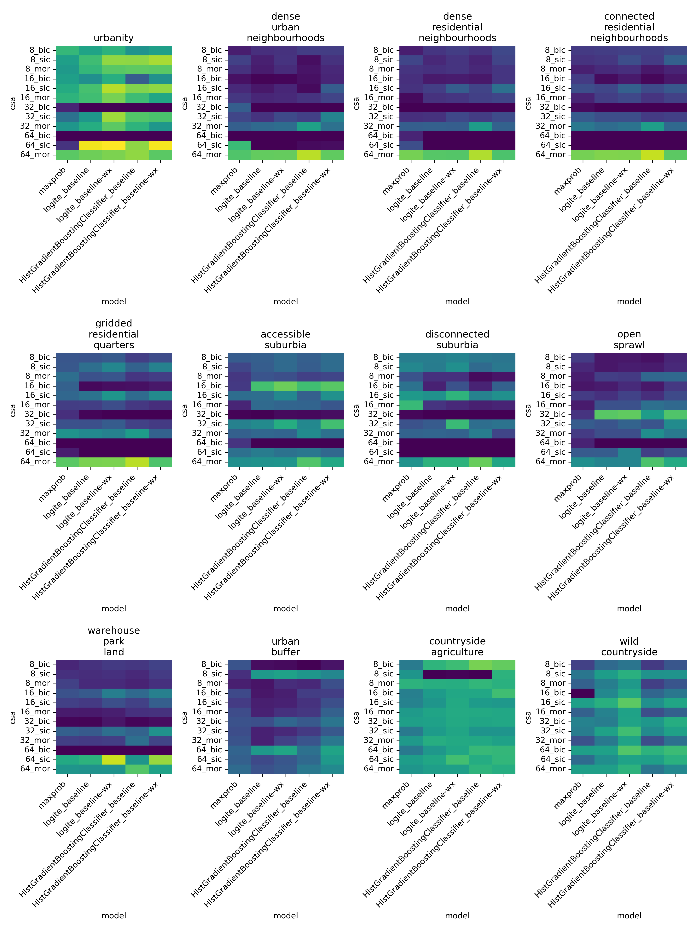

Figure 5: Within-class accuracy scores grouped by signature. Each panel represents results from one of the 12 signatures predicted. Each column in the heatmap corresponds to one of the five models compared, namely: histogram-based boosted classifier (HGBC) with features pertaining only to a given chip (baseline) or including also features from neighbouring ones (baseline-wx); Logit ensemble (logite) with the same two variations; and a simpler maximum probability approach (maxprob). Each row corresponds to a pair of chipsize (8, 16, 32, and 64 pixels) and architecture (baseline image classification, or bic; sliding image classification, or sic; and multi-output regression, or mor) used in the neural network stage of the pipeline.

## Confusion matrices

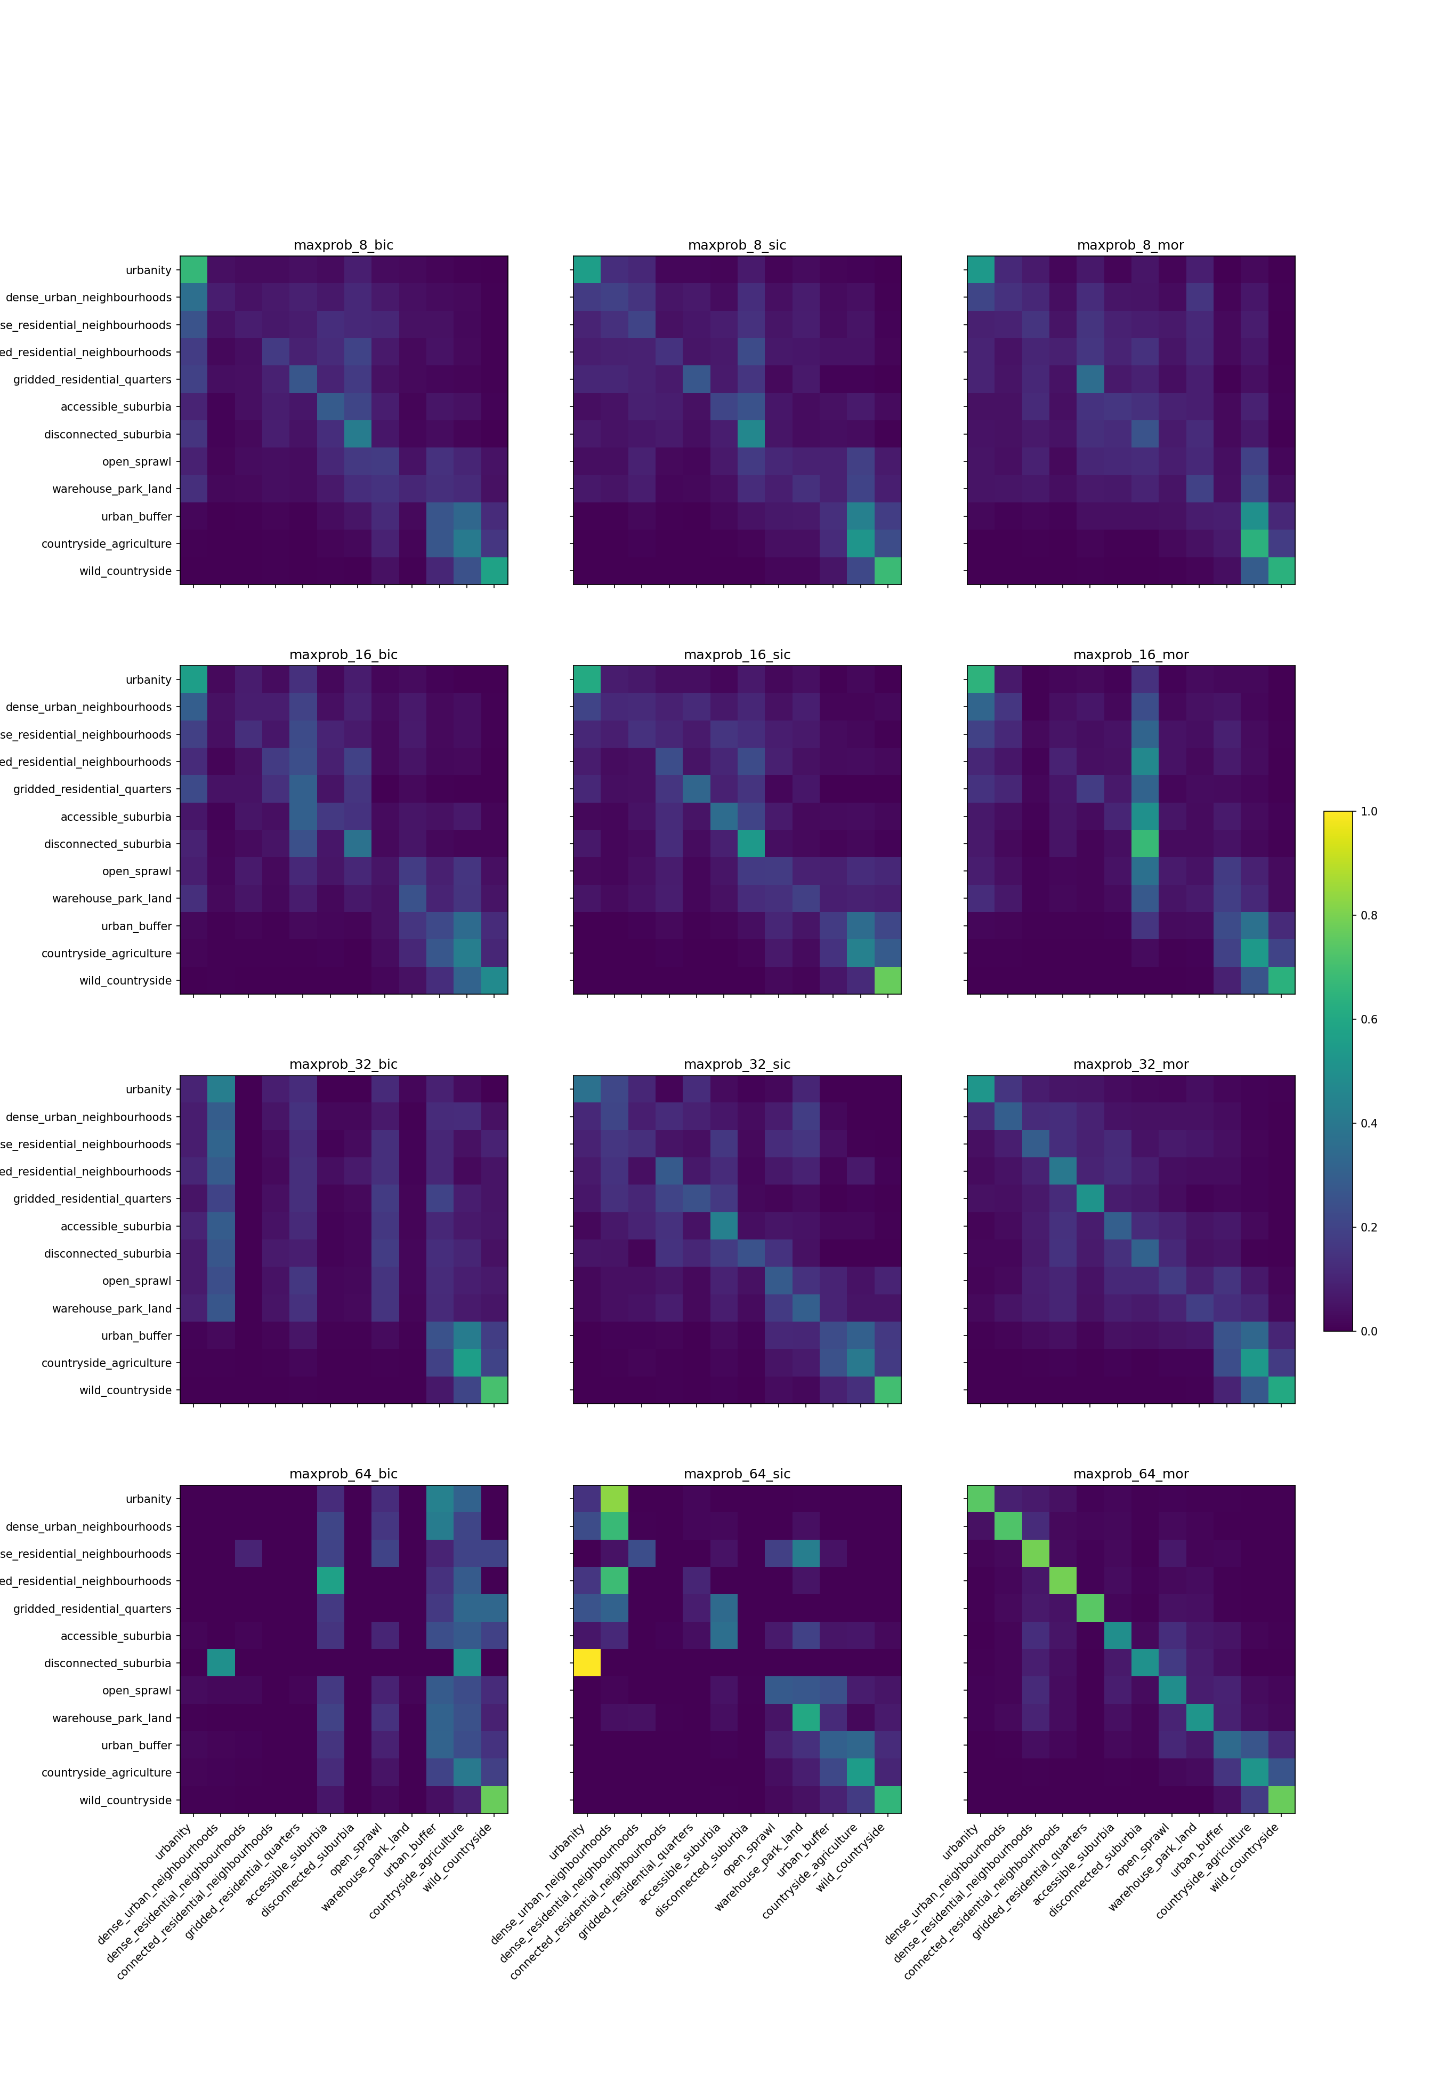

Figure 6: Confusion matrices for individual models denoting the ability of each model in prediction of a correct label per each class using the maximum probability architecture.

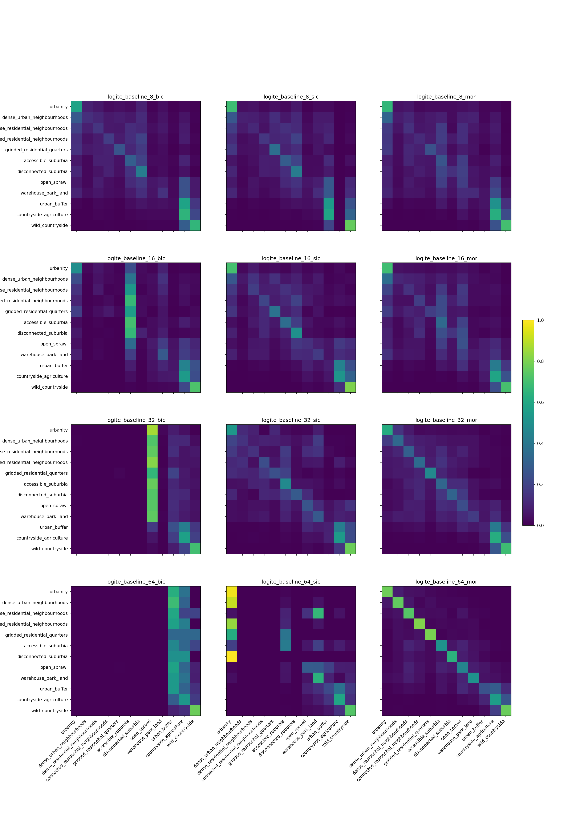

Figure 7: Confusion matrices for individual models denoting the ability of each model in prediction of a correct label per each class using the logit ensemble baseline architecture.

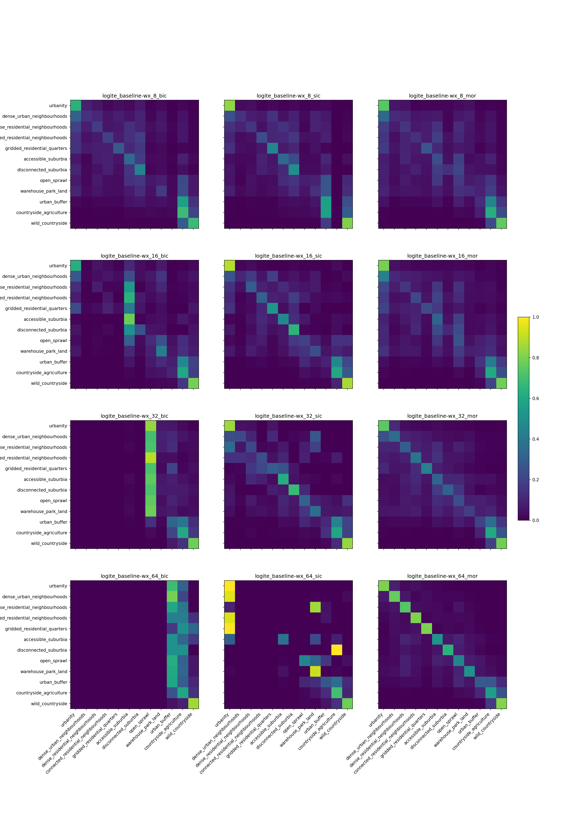

Figure 8: Confusion matrices for individual models denoting the ability of each model in prediction of a correct label per each class using the logit ensemble baseline-wx architecture.

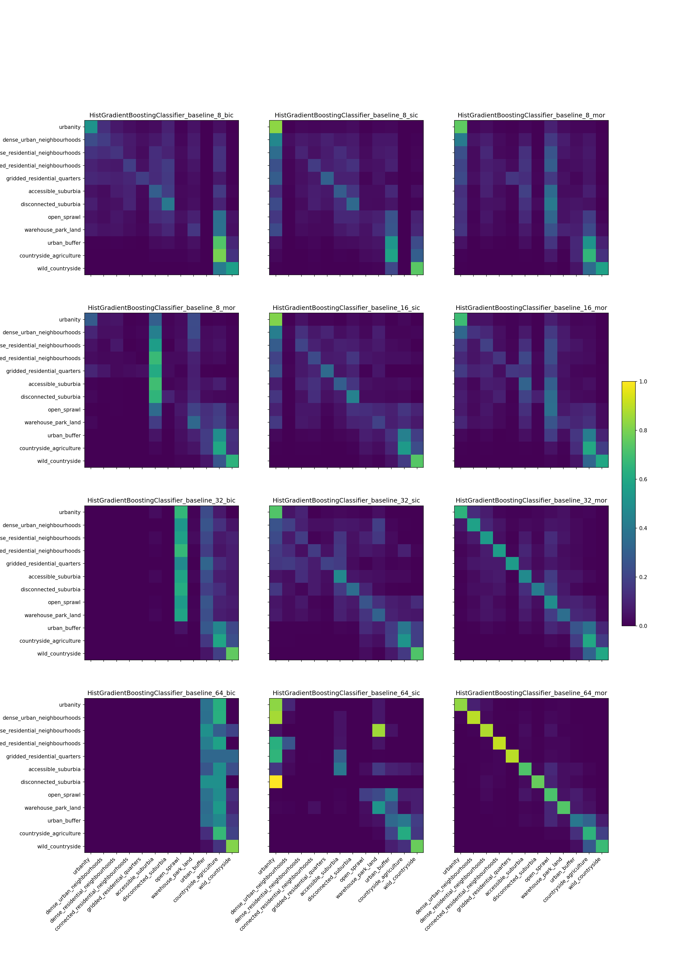

Figure 9: Confusion matrices for individual models denoting the ability of each model in prediction of a correct label per each class using the HGBC baseline architecture.

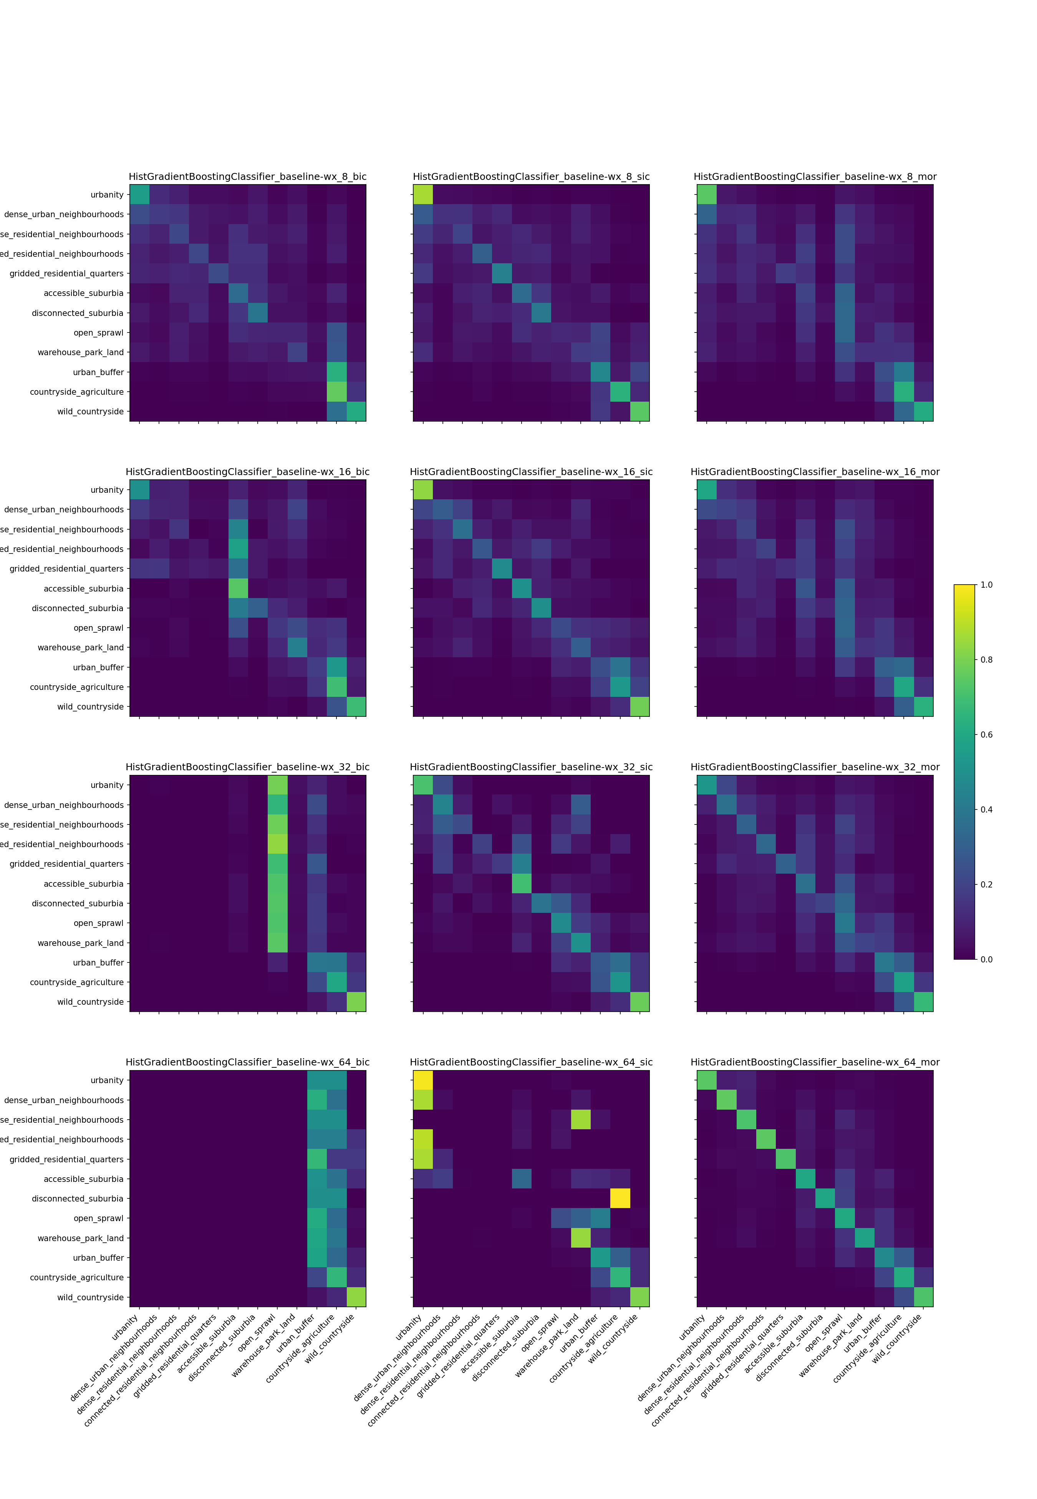

Figure 10: Confusion matrices for individual models denoting the ability of each model in prediction of a correct label per each class using the HGBC baseline-wx architecture.

## Fit of chips within signature types

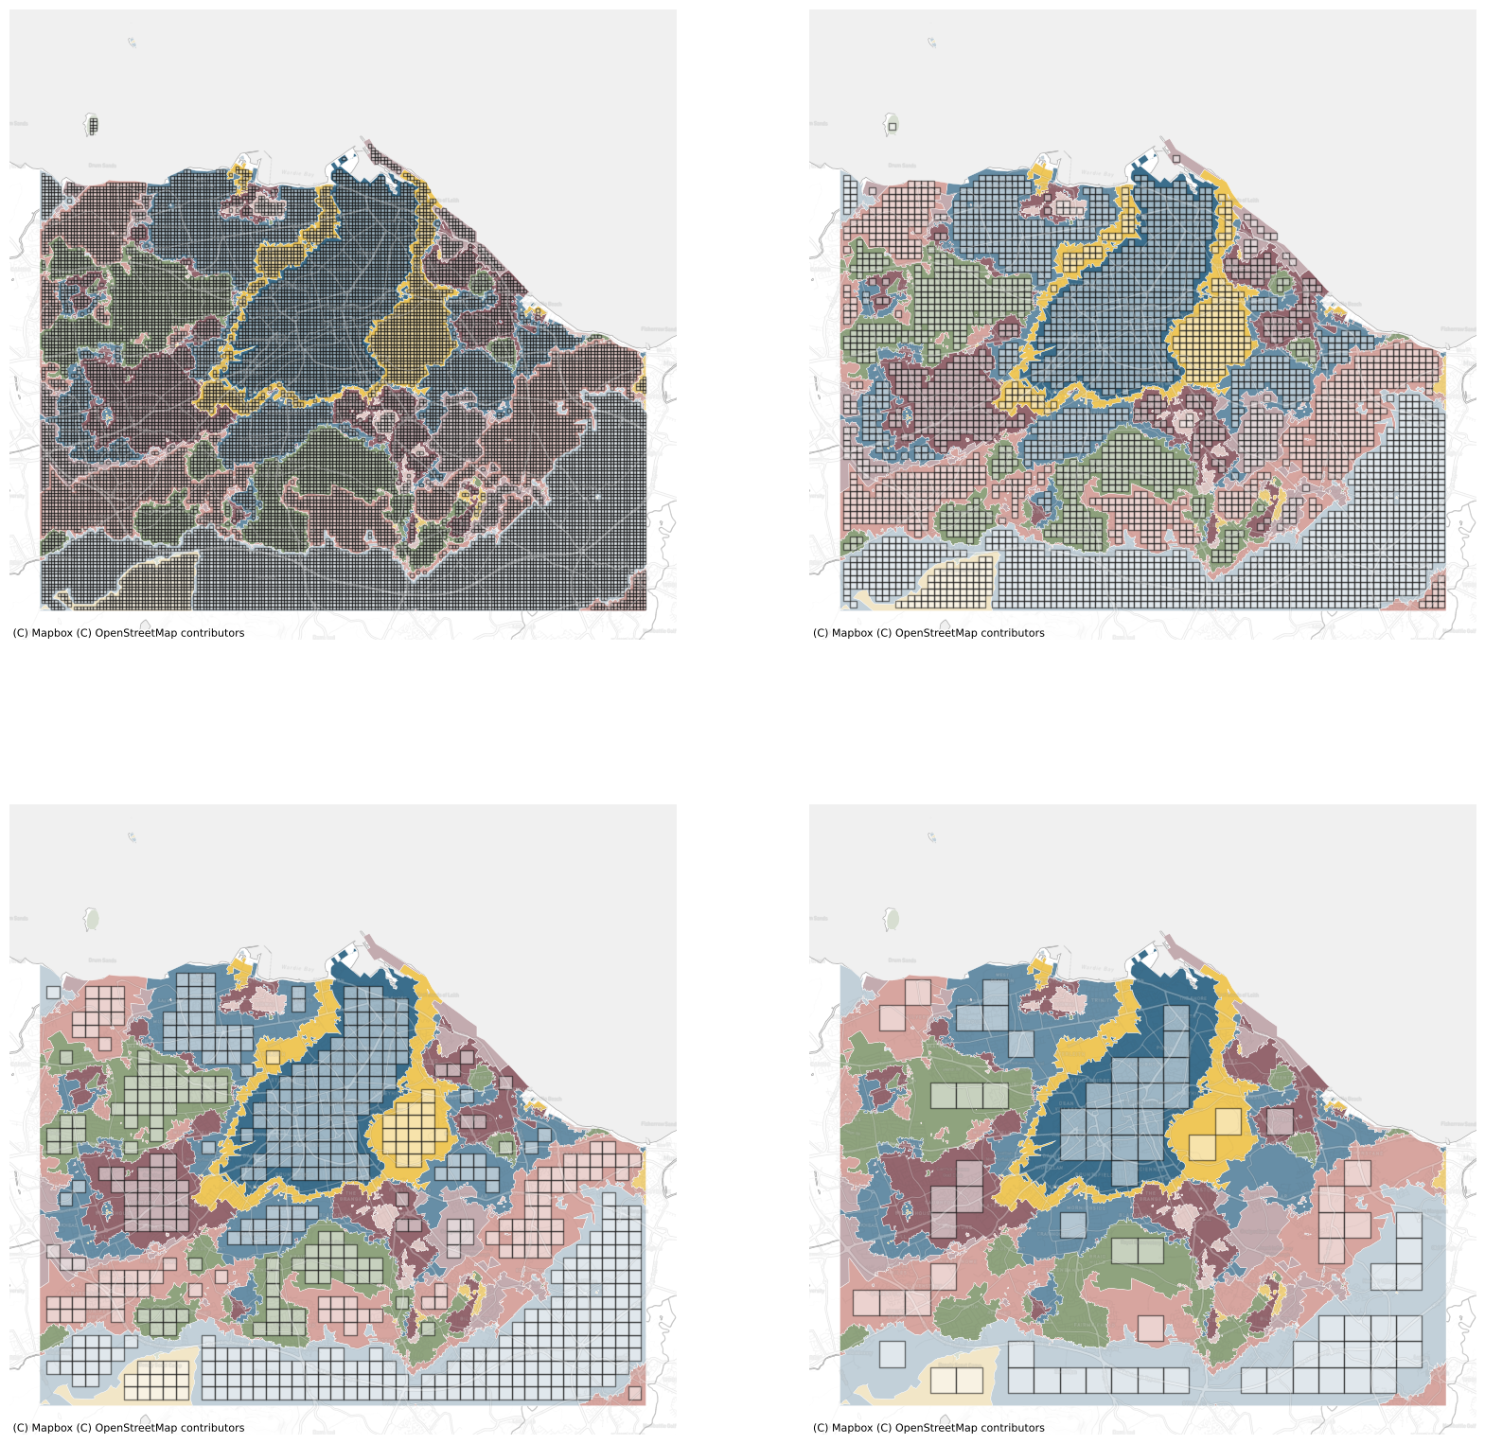

Figure 11: An illustration of the relationship between chip size and signature geometry in Edinburgh area. Subplots show all chips that represent a single class using 80 meters (top left), 160 m (top right), 320 m (bottom left) and 640 m (bottom right) chip sizes.

## Chip counts

Total number of chips (within all training, validation and secret sets) per chip size and architecture.

|  | B.I.C. | S.I.C | M.O.R. |
| --- | --- | --- | --- |
| 8 | 534,729 | 1,099,439 | 135,264 |
| 16 | 331,459 | 1,087,827 | 126,016 |
| 32 | 179,261 | 901,538 | 112,196 |
| 64 | 132,619 | 373,131 | 94,960 |

1. THANKS.
2. Geographic Data Science Lab, Department of Geography and Planning, University of Liverpool, Roxby Building , 74 Bedford St S , Liverpool , L69 7ZT, United Kingdom
3. E-mail: <M.Fleischmann@liverpool.ac.uk>; website: <https://martinfleischmann.net/>.
4. E-mail: <D.Arribas-Bel@liverpool.ac.uk>; phone: +44 (0)151 795 9727; website: <http://darribas.org>.
5. The Alan Turing Institute, British Library, 96 Euston Road, London, England, NW1 2DB, United Kingdom
6. Continuous urban fabric, Discontinuous urban fabric; Construction sites, Green urban areas, Sport and leisure facilities, Industrial or commercial units, Road and rail networks and associated land, Port areas
7. For example, commercial imagery by Maxar reaches a resolution of 30cm per pixel and imagery by Planet of 50cm per pixel
8. We remove HGBC to avoid perfect collinearity and hence treat it as the reference model.
9. We remove BIC to avoid perfect collinearity and hence treat it as the reference model.
10. We remove Accessible suburbia to avoid perfect collinearity and hence treat it as the reference model.